SY486J: Cyber Crime Investigation: Lab Six

Linux Investigation

Assigned: February 27,2019

Due Date: March 6,2019
Scenario

You’ve been hired as a computer forensic examiner by the FSB (Federal Security Bureau). Mel Torme, you’re supervisor, brings you a hard drive containing a forensic image. Mr. Torme tells you that the image was made from a hard drive that was found on the side of the road by a deputy. An anonymous caller phoned the Sheriff’s Office and told an investigator where the hard drive could be found, and that it contained evidence of possible hacking activity. The Sheriff’s Office legal team got a search warrant from a judge to search the hard drive for possible illegal hacking activity.

Tools

You will use the Kali Linux VM (not the bootable LiveCD) to conduct the analysis.

Your Job

Your job is to conduct a forensic analysis of the image in order to identify any possible hacking activity PER the search warrant (password hacking).

Note that it is not uncommon for a forensics examiner, while conducting an analysis, to come upon evidence of other illegal activity NOT PART OF THE ORIGINAL SEARCH WARRANT. When this occurs, the examiner MUST stop the examination, report the new evidence to his/her superiors, and a NEW search warrant must be obtained based on the new evidence.

For instance, you have a search warrant for hacking activity (the current assignment). If you come upon ANY OTHER possible evidence of criminal activity, you MUST obtain a new search warrant (specifics below).

The list of possible illegal activities (if they are there, it will be very apparent during a thorough investigation) might include, in addition to hacking:

- Gun running

- Underage drinking

- Insider trading

- Kitty porn (any photos of underage kittens)

- Credit card fraud/theft (stolen credit card numbers)

- Impersonating an officer

- Jay walking

I’m sure the owner of the hard drive was NOT involved in ALL of the activities, but I’m sure he/she was involved in a FEW of them.

We’ll start by searching for password cracking tools. Here are some sha1 hashes of popular tools:

- 620aca6bff27950df3ec81e9909be3e05b6bed81 john.exe

- 13f26a0a1ad0bcd0ed92f876bc4d44fdd4ca86fb Cain.exe

- c81e9909be3e05b6ed92f876bc4d44fdd4ca86fb password.exe

- 6c2ff2727411e627cb65782203d8858028dbab15 Abel64.exe

- 6d1eb2c876e3d8e648d27c7cd8ecaee0515efb24 badcracker.exe

Assumptions:

- IF YOU FIND EVIDENCE OF ANY OF THE AFOREMENTIONED LIST OF ADDITIONAL CRIMINAL ACTIVITIES, YOU MUST STOP and document that you need a new search warrant.
- You must tell me WHAT you found and request a new search warrant.

- All commands will be run from ~/evidence/lab6 unless otherwise noted.

- Complete your notes WHILE you are working through this exercise!

Deliverable
- A forensic investigation report similar to the one produced for Project 2

Simple Version of Steps Taken (yours should be a bit more detailed)

- Download the evidence file/image file from the Shared folder.

- Mount the drive read only
- Hash files

- Use hashes to search for password cracking tools
- Identify last usage of password cracking tools

- Find other evidence of password cracking, such as password hashes

- Search for graphics files
- Search for compressed files

Forensic Procedures

- Download the passcrack.dd from the Share drive or from the WHILE_GONE folder
- Copy the file into your Kali VM root directory, which is the topmost directory when log into the VM.
- Create a directory of your root directory called ‘evidence’. That is: ~/evidence

- Create a new directory under the ~/evidence directory.
  - mkdir lab6

- Mount the image on the new directory as read only
  - sudo mount –t auto –o ro,loop ./passcrack.dd ./lab6

  - Verify that the image mounted properly by running mount.
- Change directory to lab6.

- Create a hash set for all the files on the hard drive with this command:
a. sudo find . –exec sha1sum {} \; > ../passcrack.sha1 2>/dev/null

  - This command finds all files, then runs sha1sum on them. It then saves the file into the directory above lab6. The commands at the end tell the shell to ignore any errors.

- View the file updatelab.sha1.
  - less ../passcrack.sha1

  - Note that the list is not sorted. Run this command to sort the list by hash and then save to a new file.

  - sort ../passcrack.sha1 sum > ../sorted_passcrack.sha1

  - View the file using: less ../sorted_passcrack.sha1
  - You should see something that looks like this:
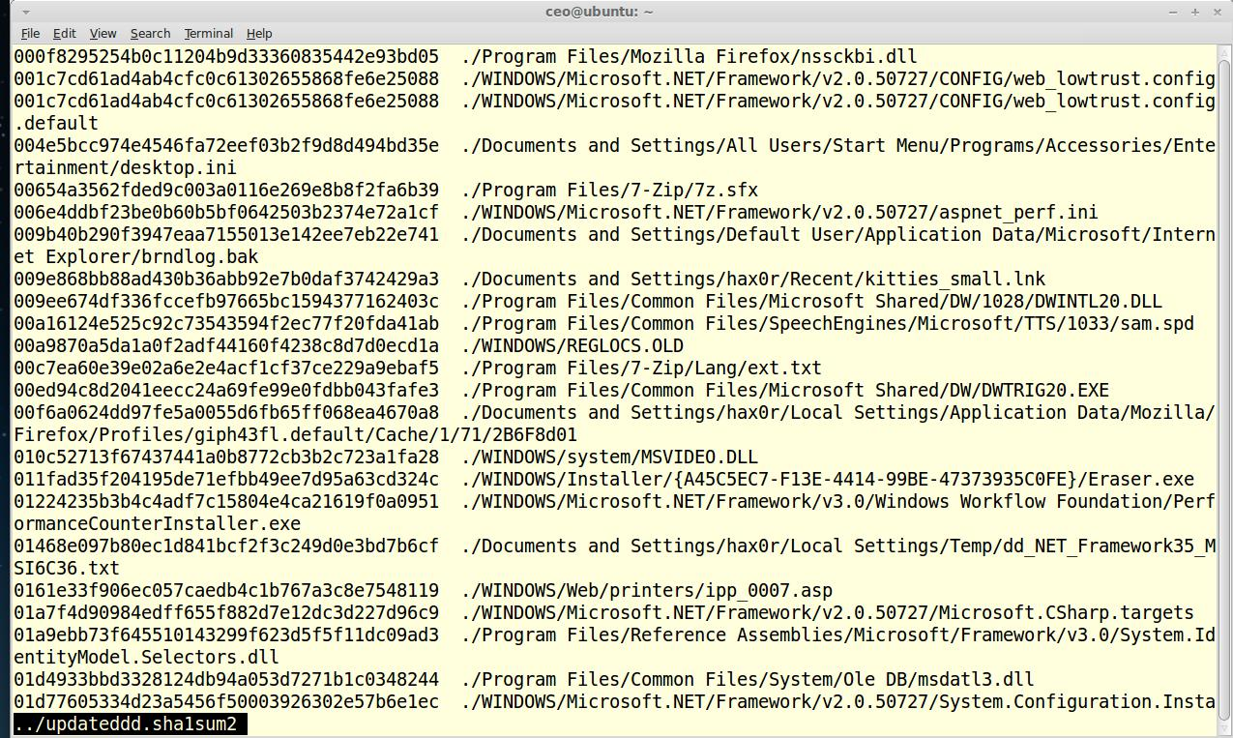

Note that the lines are now sorted by hash. We can search for the hashes of the password crackers (see Hint section above).

- Search for John the Ripper first . The first few characters of the sha1 hash are 620aca.
  - Hit the ‘/’ and then type in those characters. Hit enter. Did you find it?

  - Continue with the remaining password cracker hashes. How many did you find? Where are they located? Put this in your notes!

- View the date and time stamps for John.exe

  - cd to the directory where it’s located (the location is listed in the sorted_passcrack.sha1 file)

  - run: stat john.exe > ~/evidence/john.stat

  - Note the times when John was modified/accessed by viewing the john.stat file.

  - John saves passwords it has cracked to a file called ‘john.pot.’ See if it exists using ls –al. If it does, view the contents using “less john.pot”. What did you find?

- View the date and time stamps for all other password crackers you found. Look at the date and time stamps. Is there any indication that the programs were used?

- Search for password hashes. Password hashes for md5 are formatted thusly:
  - $1$<8 character salt>$<22 characters>

  - Use the following in C below to search:
  - grep -R '\$1\$[[:graph:]]\{8\}\$[[:graph:]]\{22\}'

  - What did you find? Where was it located?

  - What is the password for the following users?
    - Vilkp?

    - Showe?
    - Damad?

  - Let’s search for the possibility of hiding information. Let’s search for compressed files: find -name *.zip -or -name *.tgz -or -name *.tar.gz
- ../passcrack.compressed

    - This finds all commonly used compressed files with the appropriate file extension.

    - Use ‘less’ to view the file passcrack.compressed. What did you find? Interesting right?
    - Make a new directory called ‘compressed’ : mkdir ~/evidence/compressed

    - Copy the ‘interesting’ file into that newly created directory.

    - Do you need a new search warrant? ☺
    - Let’s try to unzip the file: unzip <name of file>

    - What happened? You can do one of two things, ask the suspect for the password, or you can guess. Try to guess first. Google “most common passwords” and use some of those to see if any work. If after 10 tries you haven’t opened the file, ask the suspect. Assume I’m the suspect.

  - Assume now that you have an additional warrant for stolen credit card numbers. Search using:
    - grep -R -n '[45][[:digit:]]\{15\}' > ~/evidence/creditcards.txt

    - This searches for Visa or MasterCard numbers

    - Use ‘less’ to display the contents of the file. Are there any credit card numbers? Are there any false positives? (ignore the latter).

